DISTRICT - 126 CROATIA

invites you
to the promotion of the stamp
commemorating 100 years of Lions in the world

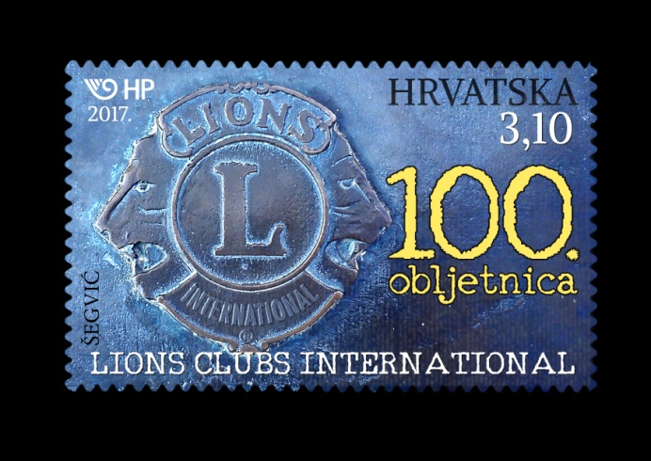

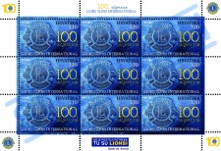

It is our honour to invite you to the promotion of the stamp and reception
on Wednesday, 7th June 2017 at 6 PM
in the 'Bruxelles' hall of Europe House in Zagreb, Jurišićeva 1/1.

The artistic program will feature the performing artist Joško Ševo, guitarist Saša Dejanović,
flautist Ana Votoupal, and soprano Antonella Malis accompanied by Franjo Bilić on the piano.

Entrance is free and all donations will be given to the Zagreb Association of Blind Persons to aid the blind and visually impaired.

We kindly ask you to confirm your participation by
Contact person: Vesna Boinović – Grubić
E-mail: vesna.boinovic.grubic@gmail.com
Mobile: + 385 98 236 - 523

Lions club Zrinjevac Governer D-126

